Department of Computer Science and Engineering (Data Science)
CSDS-A | Batch A9 (CSE - Data Science, Section A)
Privacy-Preserving Machine Unlearning in Federated LLMs: A Certified Right-to-Be-Forgotten Framework
(ForgetSafe)
S.No. | Student name | Roll / hall ticket no.
1 | G.SHASHANK | 23K91A6761
2 | B.SATHISH | 23K91A6719
3 | G.RAKESH | 23K91A6759
4 | B.AKHIL | 23K91A6721
Under the guidance of: [GUIDE NAME], [DESIGNATION]
DESIGN AND IMPLEMENTATION
This document describes the design of ForgetSafe and how it was implemented: the architecture, the modules, the data model, the API, key code walkthroughs, and the reasoning behind the main implementation decisions.

1 System Architecture
ForgetSafe is a single-machine application in two parts: a Python back end that uses only the standard library, and a React front end built with Vite. The back end contains the whole domain logic (the federated aggregation, the unlearning, the verification and the audit ledger) and exposes it as a small JSON API; the front end is a client of that API and holds no domain logic. The original single-page interface and the Tkinter window of the first version were kept, so the same engine is reachable through four front doors. No external service is called and no network access is needed after the front-end dependencies are installed.
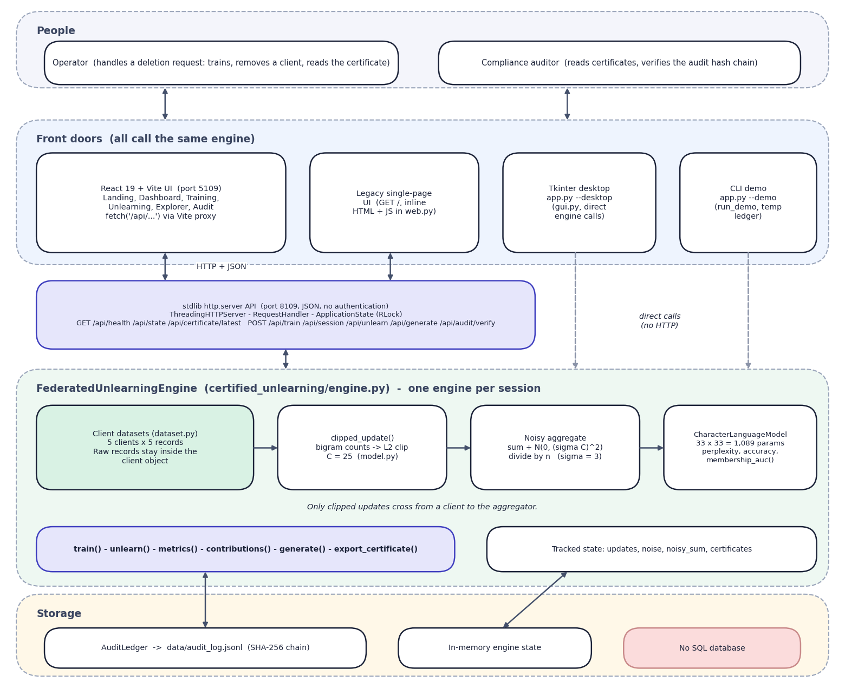
Fig. 1: System architecture of ForgetSafe
The diagram has five bands. At the top are the two kinds of person who use the system: the operator, who handles a deletion request by training, removing a client and reading the certificate, and the compliance auditor, who reads certificates and verifies the audit chain. Below them are four front doors that all call the same engine: the React web application on port 5109, which reaches the Python server through the Vite proxy with HTTP and JSON; the original single-page interface that the Python server returns at /; the Tkinter desktop window started with python app.py --desktop; and the terminal demonstration started with --demo. The last two call the engine directly (dashed arrows).
The third band is the standard-library API on port 8109 (ThreadingHTTPServer, the request handler and ApplicationState with its re-entrant lock; JSON, no authentication), and the figure lists the nine routes it serves. The fourth band is the FederatedUnlearningEngine, one per session. Inside it the client datasets, the clipped-update step, the noisy aggregate and the character language model form a left-to-right chain, a note states that only clipped updates cross from client to aggregator, and the engine's operations (train, unlearn, metrics, contributions, generate, export_certificate) and tracked state (updates, noise, noisy sum, certificates) sit below the chain. The bottom band is storage: the hash-chained ledger file, the in-memory engine state, and an explicit 'No SQL database' box.
Five design principles shaped the architecture.
1. Keep the guarantee in one place. Everything that decides whether a removal is certified lives in FederatedUnlearningEngine.unlearn(); the web handler, the React pages and the Tkinter window only call it and display what it returns, so no front end can certify something the engine did not.
2. Separate the model from the orchestration. The language model (model.py) knows only a flat parameter vector and four metrics. The engine treats the vector as the shared state, so the proxy can later be replaced by an adapter tensor of a real model without changing the orchestration, the certificate schema or the ledger. Reference [22] describes the low-rank adapter update that the proxy stands in for.
3. Make every deletion leave evidence. Training and unlearning both end in a ledger append; there is no code path that changes the model without writing an audit record.
4. Dependency-free back end. Using http.server, dataclasses, hashlib and json means the demonstration runs on any machine with Python 3.10 or newer, which matters for a project that is presented on a classroom computer.
5. Honest labelling. The interface states that the model is a demonstrator (a note in the sidebar), and the certificate shows its method string, so nobody reading it can mistake the proxy for a formally erased LLM.
Table 1: Layers of the architecture
Layer | Technology | Main files | Responsibility
Presentation (web) | React 19, React Router 7, Recharts, Framer Motion, Vite 8 | frontend/src/pages/*.jsx, components/ui/* | Landing page and five application pages; charts, tables, dialogs, toasts
Presentation (legacy) | HTML/JS string inside web.py; Tkinter | web.py (PAGE), gui.py | Original four-tab interface; desktop window
API | http.server.ThreadingHTTPServer | web.py | Routing, JSON encoding, input checks, status codes, one lock
Domain | Python dataclasses | engine.py | Training, unlearning, verification, certificate
Model | Pure Python lists | model.py | Bigram counts, clipping, probabilities, perplexity, accuracy, membership AUC
Evidence | SHA-256 over canonical JSON, JSONL file | audit.py, data/audit_log.jsonl | Append-only hash chain and its verification
Data | Python constants | dataset.py | Five client corpora, public evaluation set, non-member set

Trust boundary. The federated learning rule is that raw data stays with the client and only an update crosses to the coordinator. In ForgetSafe the clients are ClientDataset objects and the coordinator is the engine, in one process. train() reads client.records to build each update, and the engine keeps every clipped update afterwards, because exact subtraction needs them. The boundary is therefore a convention of the code and not a separation of machines, and the stored updates are exactly the sensitive artefacts that a real deployment would have to encrypt and restrict, as PROJECT_REPORT.md itself notes.

2 Module Design
The code base is small enough to describe module by module. Line counts below were taken from the files when this report was built.
Table 2: Back-end and test modules
Module | Lines | Responsibility | Key functions and classes
certified_unlearning/engine.py | 297 | Lifecycle of a session: train, unlearn, verify, certify, export | FederatedUnlearningEngine, TrainingMetrics, ClientContribution, UnlearningCertificate, _vector_hash()
certified_unlearning/model.py | 122 | Character-bigram model and its numerical helpers | normalize_text(), raw_update(), clipped_update(), l2_norm(), CharacterLanguageModel, membership_auc()
certified_unlearning/audit.py | 65 | Append-only hash-chained ledger | AuditLedger.append(), verify(), read_all(), GENESIS_HASH
certified_unlearning/dataset.py | 101 | Built-in corpora | CLIENTS, PUBLIC_EVALUATION, NON_MEMBER_TEXTS, ClientDataset
certified_unlearning/web.py | 247 | HTTP server, JSON API and the legacy page | PAGE, ApplicationState, make_handler(), run_web()
certified_unlearning/gui.py | 379 | Tkinter desktop interface | UnlearningApp, run_gui()
app.py | 59 | Entry point with three modes | run_demo(), main() (--demo, --desktop, --port, --host, --open-browser)
tests/test_end_to_end.py | 85 | Unit and endpoint tests (5 tests) | FederatedUnlearningTests
scripts/smoke_test.py | 120 | End-to-end API check (14 checks) | run(), call(), check()

web.py holds the single largest block of text, but most of it is the embedded legacy page (about 90 lines of HTML, CSS and JavaScript); its Python logic is about 140 lines from ApplicationState to run_web().

2.1 Engine module
engine.py is the module that carries the project's claim. train() builds one clipped update per client, draws the noise with random.Random(seed).gauss, forms the noisy sum and builds the model. unlearn() guards the request, subtracts, rebuilds, measures and certifies. metrics() computes perplexity, accuracy, the composite utility score and the SHA-256 fingerprint of the parameter vector (the vector rounded to 12 decimals and serialised as compact JSON). contributions() exposes the per-client norms that the training page charts, and _reference_parameters() builds the retained-only recomputation that the certificate compares against.

2.2 Model module
model.py defines the 33-symbol alphabet (the start marker ^, the end marker $, space, the 26 lower-case letters and four punctuation marks), and keeps the 1,089-element parameter vector as a flat list in row-major order, so that the entry for the transition from character a to character b is at index(a) * 33 + index(b). Probabilities are computed row by row: the parameter is clamped at zero, the smoothing constant 0.15 is added, the entry for the start marker is zeroed so that the model never emits it, and the row is normalised. This clamping is what lets a noisy, partly negative parameter vector still define a valid distribution.

2.3 Audit module and web module
audit.py has no dependency on the rest of the package. It hashes with hashlib.sha256 and writes with an explicit \n newline so that the file is byte-identical across operating systems. web.py builds the handler class inside make_handler(application) so that the handler closes over one ApplicationState; the tests exploit this by starting a server on an spare port with their own temporary ledger.

2.4 Front-end modules
Table 3: Front-end modules
Path | Lines | Role
frontend/src/main.jsx | 22 | Mounts theme, toast and lab providers and the router
frontend/src/App.jsx | 43 | Route table; lazy-loads each page
frontend/src/lib/api.js | 40 | Thin fetch client for the eight JSON endpoints; turns {error} bodies into ApiError
frontend/src/lib/lab.jsx | 34 | LabProvider and useLab(): the single copy of GET /api/state
frontend/src/lib/theme.jsx | 46 | Light and dark theme, persisted in localStorage
frontend/src/pages/Dashboard.jsx | 93 | Workflow stepper, four metric tiles, client-norm chart, latest certificate
frontend/src/pages/Training.jsx | 125 | Train, retrain and new-session actions with confirmation dialogs; clients table and norm chart
frontend/src/pages/Unlearning.jsx | 136 | Client selector, confirmation dialog, certificate view, before and after charts
frontend/src/pages/Explorer.jsx | 88 | Seed field, sample list tagged with client count and model hash
frontend/src/pages/Audit.jsx | 62 | Chain status, searchable ledger table, record viewer
frontend/src/pages/Landing.jsx | 261 | Public landing page with live counters from /api/state
frontend/src/pages/shared.jsx | 193 | CertificateView, AuditTable, ClientsTable, status badges
frontend/src/pages/useAction.js | 30 | Runs an API call, refreshes state, shows a success or error toast
frontend/src/components/ui/* | 1296 | Button, Card, Table, Modal, Toast, Layout, Skeleton and other building blocks
frontend/src/components/charts/index.jsx | 202 | Recharts wrappers: bar, grouped bar, line, area

3 Data Design
ForgetSafe has no SQL or document database. This is a deliberate consequence of the problem it demonstrates: the evidence that must last is the audit ledger, and the working state of a session is cheap to recompute from a seed. The data model therefore has two parts: state held in memory by the engine, and one append-only file.
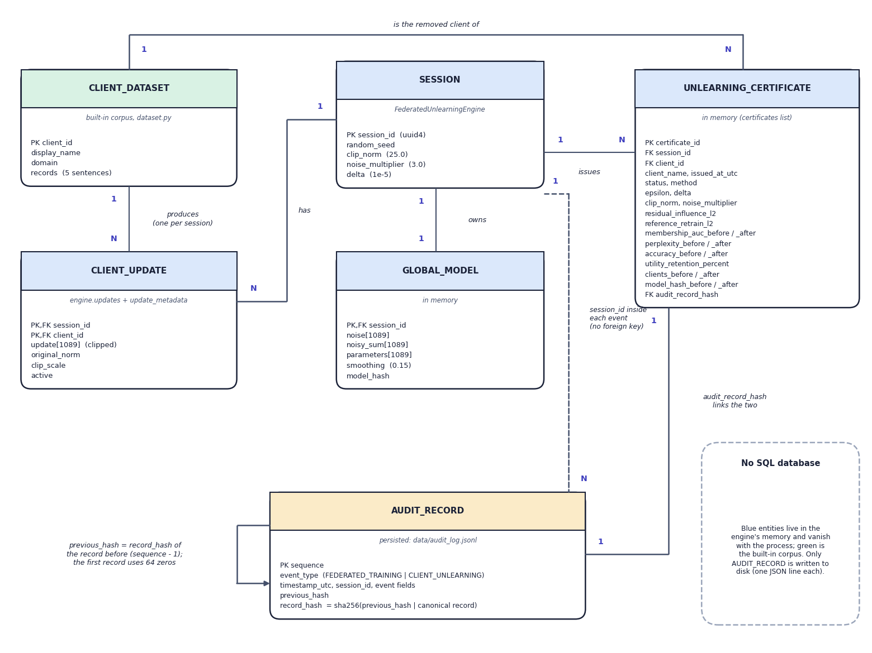
Fig. 2: Entity-relationship view of the data model (no SQL database)
ForgetSafe has no relational database, so the diagram shows the entities of its data model and how they relate; a note in the corner says so, and colour separates the in-memory entities (blue and green) from the persistent one (amber). A client dataset produces one client update per session, and a session has one update for each client, one global model (the noise, the noisy sum, the parameters and the model hash) and any number of certificates. Each certificate names the client dataset it removed and is linked one-to-one with an audit record through audit_record_hash. The audit record carries the session id inside its event fields but has no foreign key, and its previous_hash points to the record before it, the first record using 64 zeros, which is the self-link that forms the chain. Only the audit record is written to disk, as one JSON line of data/audit_log.jsonl.

3.1 In-memory state of a session
Table 4: Engine state
Attribute | Type | Set by | Meaning
session_id | str (UUID4) | __init__ | Identifies the session in events and certificates
clients | dict[str, ClientDataset] | __init__ | Five clients; raw records (D1)
updates | dict[str, list[float]] | train() | Clipped bigram-count vector per client, 1,089 floats each
update_metadata | dict[str, (float, float)] | train() | Original L2 norm and clip scale per client
active_client_ids | list[str] | train(), unlearn() | Clients still contributing to the model
noise | list[float] | train() | One Gaussian draw, standard deviation sigma times C per coordinate; kept for the whole session
noisy_sum | list[float] | train(), unlearn() | Sum of active clipped updates plus the noise
model | CharacterLanguageModel or None | _rebuild_model() | noisy_sum divided by the active-client count
certificates | list[UnlearningCertificate] | unlearn(); cleared by train() | Certificates of the current session

None of this state is written to disk. After a server restart the engine is untrained, and only the ledger shows what happened before. The random seed (2026 by default) makes the noise repeatable: the same seed gives the same noise and therefore the same model hash, which is what makes the experiments of the results chapter reproducible.

3.2 Audit ledger records
The ledger is a JSON-lines file; each line is one record. The path is data/audit_log.jsonl relative to the directory from which the server is started, and the file is excluded from version control. Every record carries the three chain fields, and the remaining fields depend on the event type.
Table 5: Ledger record schema
Field | Event types | Description
sequence | both | 1-based position in the ledger
previous_hash | both | record_hash of the preceding record; 64 zeros for the first
record_hash | both | SHA-256 of previous_hash, a vertical bar and the canonical JSON of the record without this field
event_type | both | FEDERATED_TRAINING or CLIENT_UNLEARNING
timestamp_utc | training | ISO-8601 time, seconds precision
session_id, active_clients, epsilon, delta, clip_norm, noise_multiplier, model_hash | training | Configuration and fingerprint of the trained model (epsilon rounded to 8 places)
all 25 certificate fields | unlearning | The certificate, whose issued_at_utc serves as the time

One detail follows from the order of operations. The certificate is appended to the ledger before its own record hash exists, so the ledger copy holds an empty audit_record_hash; the engine then stores the returned record_hash in the certificate object that is handed back to the caller. The certificate a user downloads therefore points to its ledger record, and the ledger record does not point back, which is acceptable because the record's position in the chain already identifies it.

3.3 Certificate schema
Table 6: The 25 fields of an unlearning certificate
Group | Fields
Identity | certificate_id (CERT- and 12 hex digits), session_id, client_id, client_name, issued_at_utc
Decision | status (CERTIFIED or REVIEW_REQUIRED), method (fixed string: tracked clipped-update subtraction with retained-client renormalization)
Privacy parameters | epsilon, delta, clip_norm, noise_multiplier
Verification | residual_influence_l2, reference_retrain_l2 (the same number in this implementation), membership_auc_before, membership_auc_after
Utility | perplexity_before, perplexity_after, accuracy_before, accuracy_after, utility_retention_percent
Population and integrity | clients_before, clients_after, model_hash_before, model_hash_after, audit_record_hash

Two limits of this design are stated here because they affect how the evidence can be used. The ledger append reads the whole file to find the previous hash, so its cost grows with the ledger (the results chapter measures 0.44 ms at one record and 19.6 ms at 2,000). And two server processes started in the same directory would write to the same file without any file lock; the RLock in ApplicationState protects threads of one process only.

4 Application Architecture
At run time ForgetSafe is two processes. The Python process serves the API on port 8109 (python app.py --port 8109; the default when no port is given is 8000, which serves the original interface). The Node process runs the Vite development server on port 5109 with strictPort, bound to 127.0.0.1, and proxies /api to the Python process, so the browser sees one origin and no cross-origin headers are needed. The two port numbers are read from the project's environment file by run.bat and by vite.config.js (BACKEND_PORT and FRONTEND_PORT), with 8109 and 5109 as defaults.
Inside the Python process ThreadingHTTPServer starts one thread per connection. A single ApplicationState holds the engine and a re-entrant lock; every route that touches the engine runs inside with application.lock, so two simultaneous requests are serialised and the engine never sees a half-updated state. The engine is replaced as a whole on POST /api/session, and there is exactly one engine for all callers: two browser tabs share one session.
Table 7: Technology stack
Component | Technology (as declared) | Purpose
Back end | Python 3.10+ standard library (measured on 3.11.9) | Engine, model, ledger, HTTP server
UI framework | React 19, React DOM 19 | Pages and components
Routing | React Router 7 | Seven routes: landing, five application pages and a not-found page
Build and dev server | Vite 8, @vitejs/plugin-react | Bundling, hot reload, /api proxy
Charts | Recharts 3 | Bar, grouped-bar, line and area charts
Motion | Framer Motion 14, GSAP 3, Lenis | Page transitions, count-up, smooth scrolling
Icons and effects | lucide-react, canvas-confetti | Icons
Desktop UI | Tkinter (standard library) | Original desktop window

The front end can also be built for production with npm run build; npm run preview serves the build on the same port and keeps the same proxy. The Python server does not serve the React build, so a deployment would need a reverse proxy in front of both. This is recorded as future work and is not hidden by the run script.

5 API Design
The API is a small JSON interface over HTTP defined in certified_unlearning/web.py. All responses use Content-Type: application/json; charset=utf-8 and Cache-Control: no-store, except the legacy page at /, which is HTML. Errors are always an object with one error string. Request bodies are JSON objects; the only endpoints that read a body are /api/unlearn (client_id) and /api/generate (seed).
Table 8: API endpoints
Method | Path | Request body | Success response | Error responses
GET | / | - | HTML page of the original interface | -
GET | /api/health | - | {status, service} | -
GET | /api/state | - | {trained, session_id, metrics, contributions[], active_clients[], latest_certificate, audit{valid, detail, records[]}} | 500
GET | /api/certificate/latest | - | Certificate fields plus audit_valid, audit_verification; Content-Disposition attachment | 404 if none
POST | /api/train | none | TrainingMetrics | 400, 500
POST | /api/session | none | {session_id} | 400, 500
POST | /api/unlearn | {client_id} | UnlearningCertificate (25 fields) | 400 untrained, unknown, repeated, last client, missing id
POST | /api/generate | {seed} | {text} | 400 before training
POST | /api/audit/verify | none | {valid, detail} | 400, 500

The handler maps exceptions to status codes in one place: ValueError, KeyError, RuntimeError and json.JSONDecodeError raised in a POST become HTTP 400 with the exception text; any other exception becomes HTTP 500; an unknown route is HTTP 404. A certificate request before any removal is HTTP 404. The example below is the certificate returned when Client 01 (Finance) is removed in the default run (seed 2026); the fields are abbreviated to the ones that decide the outcome.
Listing: request and (abbreviated) response
POST /api/unlearn {"client_id": "client_finance"}
{
"certificate_id": "(random per run)",
"client_name": "Client 01 (Finance)",
"status": "CERTIFIED",
"epsilon": 1.6149350875351296,
"delta": 1e-05,
"reference_retrain_l2": 2.7903189690385764e-14,
"membership_auc_before": 0.2,
"membership_auc_after": 0.16,
"perplexity_before": 130.22138531571318,
"perplexity_after": 146.47196760072828,
"utility_retention_percent": 93.64532042042157,
"clients_before": 5,
"clients_after": 4
}

Behaviour at the edges was measured against the live server (the results chapter discusses it). The table gives the observed status for each case; an oversized body does not reach the client as an HTTP response.
Table 9: Measured API behaviour at the edges
Case | HTTP status | Observed response
unlearn before training | 400 | Train the federated model before requesting unlearning
generate before training | 400 | Train the federated model first
certificate before any unlearning | 404 | No certificate is available
unknown route (GET) | 404 | Route not found
unknown route (POST) | 404 | Route not found
malformed JSON body | 400 | Expecting property name enclosed in double quotes: line 1 column 2 (ch...
JSON array instead of object | 400 | JSON body must be an object
oversized body (2 MB) | connection aborted | [WinError 10053] An established connection was aborted by the software...
unlearn without client_id | 400 | client_id is required
unlearn unknown client id | 400 | 'Unknown client: client_nobody'
unlearn with SQL-ish id | 400 | "Unknown client: x'; DROP TABLE--"
generate with empty seed | 200 | accepted
generate with unicode seed | 200 | accepted
generate with 5,000-char seed | 200 | accepted
unsupported method (PUT) | 501 | stdlib HTML 501 page
unlearn first client ok | 200 | accepted
repeat unlearn same client | 400 | client_finance has already been unlearned
unlearn the last remaining client | 400 | At least one client must remain in the model
path traversal on / | 404 | Route not found
legacy single-page UI at / | 200 | html

Two behaviours are defects rather than design. When a body exceeds 1,000,000 bytes the handler raises before reading it and the connection is closed, so a client sees a reset instead of a clean 400. And a method that the handler does not define (for example PUT) returns the HTML error page of the standard library, not a JSON error. Neither affects the main flow.

6 Key Code Walkthroughs
Five short excerpts carry the logic of the system. They are copied from the source files without change.

6.1 Training: clip, sum, add noise
Listing: `FederatedUnlearningEngine.train()` (engine.py)
def train(self) -> TrainingMetrics:
rng = random.Random(self.random_seed)
self.updates.clear()
self.update_metadata.clear()
self.active_client_ids = list(self.clients)
clean_sum = [0.0] * DIMENSION
for client_id, client in self.clients.items():
update, original_norm, scale = clipped_update(client.records, self.clip_norm)
self.updates[client_id] = update
self.update_metadata[client_id] = (original_norm, scale)
for index, value in enumerate(update):
clean_sum[index] += value

noise_stddev = self.noise_multiplier * self.clip_norm
self.noise = [rng.gauss(0.0, noise_stddev) for _ in range(DIMENSION)]
self.noisy_sum = [value + noise for value, noise in zip(clean_sum, self.noise)]
self._rebuild_model()

The random generator is seeded, so the same seed reproduces the same noise and the same model hash. Each client's update is computed by clipped_update, stored in self.updates together with its original norm and scale, and added to clean_sum. The noise vector is drawn once, with a standard deviation of noise multiplier times clip norm for every coordinate, and added to form noisy_sum; the model is noisy_sum divided by the client count. Only noisy_sum and the model are used for the model; the stored updates and noise are what make removal possible later.

6.2 Unlearning: guards
Listing: guards of `unlearn()` (engine.py)
def unlearn(self, client_id: str) -> UnlearningCertificate:
if self.model is None:
raise RuntimeError("Train the federated model before requesting unlearning")
if client_id not in self.clients:
raise KeyError(f"Unknown client: {client_id}")
if client_id not in self.active_client_ids:
raise ValueError(f"{client_id} has already been unlearned")
if len(self.active_client_ids) <= 1:
raise ValueError("At least one client must remain in the model")

Four conditions raise before any state changes: the model has not been trained, the client id is unknown, the client was already removed, or only one client is left. The untrained case raises RuntimeError, the unknown id KeyError, and the other two ValueError; the web layer maps all of them to HTTP 400.

6.3 Unlearning: subtraction, reference and decision
Listing: core of `unlearn()` (engine.py)
target_update = self.updates[client_id]
self.noisy_sum = [aggregate - value for aggregate, value in zip(self.noisy_sum, target_update)]
self.active_client_ids.remove(client_id)
self._rebuild_model()

after = self.metrics()
auc_after = membership_auc(self.model, client.records, NON_MEMBER_TEXTS)
reference = self._reference_parameters(self.active_client_ids)
difference = [actual - expected for actual, expected in zip(self.model.parameters, reference)]
reference_distance = l2_norm(difference)
# Because the stored update is subtracted algebraically, its coefficient
# in the retained aggregate is exactly zero (within floating-point error).
residual_influence = reference_distance
retention = self._utility_retention(before, after)
status = "CERTIFIED" if reference_distance <= 1e-10 and retention >= 70.0 else "REVIEW_REQUIRED"

The first three statements are the unlearning: subtract the stored update from the noisy sum, drop the client from the active list and rebuild the model. The reference is then recomputed by _reference_parameters, which starts from the same stored noise and adds the retained updates. The comment in the source records the point made earlier in this chapter: the coefficient of the removed update in the retained aggregate is zero by algebra, so the distance is rounding error. The decision on the last line combines that distance with the retention threshold.
Listing: `_reference_parameters()` (engine.py)
def _reference_parameters(self, retained_ids: list[str]) -> list[float]:
reference_sum = list(self.noise)
for client_id in retained_ids:
for index, value in enumerate(self.updates[client_id]):
reference_sum[index] += value
return [value / len(retained_ids) for value in reference_sum]

6.4 Membership inference
Listing: `membership_auc()` (model.py)
def membership_auc(model: CharacterLanguageModel, members: Iterable[str], non_members: Iterable[str]) -> float:
"""Return attack AUC where lower language-model loss predicts membership."""

member_scores = [-model.negative_log_likelihood(text) for text in members]
non_member_scores = [-model.negative_log_likelihood(text) for text in non_members]
if not member_scores or not non_member_scores:
return 0.5
wins = 0.0
for member in member_scores:
for non_member in non_member_scores:
if member > non_member:
wins += 1.0
elif member == non_member:
wins += 0.5
return wins / (len(member_scores) * len(non_member_scores))

The score of a text is its negative loss, so a lower loss means a higher membership score. The function counts the fraction of (member, non-member) pairs that the score orders correctly, with ties worth one half, which is the Mann-Whitney form of the area under the ROC curve. With five texts on each side there are 25 pairs, so the value moves in steps of 0.04. When a set is empty the function returns 0.5.

6.5 The audit ledger
Listing: `AuditLedger.append()` and `verify()` (audit.py)
def append(self, event: dict[str, Any]) -> dict[str, Any]:
records = self.read_all()
previous_hash = records[-1]["record_hash"] if records else GENESIS_HASH
record = dict(event)
record["sequence"] = len(records) + 1
record["previous_hash"] = previous_hash
record_hash = hashlib.sha256(f"{previous_hash}|{_canonical(record)}".encode("utf-8")).hexdigest()
record["record_hash"] = record_hash
with self.path.open("a", encoding="utf-8", newline="\n") as handle:
handle.write(json.dumps(record, sort_keys=True) + "\n")
return record

def verify(self) -> tuple[bool, str]:
previous_hash = GENESIS_HASH
try:
records = self.read_all()
except ValueError as error:
return False, str(error)
for expected_sequence, record in enumerate(records, start=1):
stored_hash = record.get("record_hash", "")
payload = {key: value for key, value in record.items() if key != "record_hash"}
calculated = hashlib.sha256(f"{previous_hash}|{_canonical(payload)}".encode("utf-8")).hexdigest()
if record.get("sequence") != expected_sequence:
return False, f"Sequence mismatch at record {expected_sequence}"
if record.get("previous_hash") != previous_hash or stored_hash != calculated:
return False, f"Hash-chain verification failed at record {expected_sequence}"
previous_hash = stored_hash
return True, f"Verified {len(records)} audit record(s)"

append reads the whole ledger, takes the previous record's hash (or 64 zeros), adds the sequence number and the previous hash to the record, hashes the string of previous hash, a bar and the canonical JSON (sorted keys, compact separators, ASCII only), and writes the record with its own hash as one line. verify walks the file from the start, recomputes each hash from the record minus its record_hash field, and checks the sequence number, the link and the hash; it returns the number of the first record that fails. Reading the file in append is why the cost grows with the ledger, and the absence of any secret in the hash is why a forger who recomputes every hash cannot be detected.

7 Implementation Decisions and Their Reasoning
A small system is made of a small number of decisions, and each of them fixes something that the evidence of Chapters 7 and 8 later measures. The table lists the main decisions, the reason for each and what it cost; the paragraphs that follow explain the three decisions that shape the results most.
Table 10: Main implementation decisions
Decision | Reason | Cost
Python standard library only for the engine and the API | runs offline on a classroom computer with no installation; every line is inspectable; reproducible by python app.py | hand-written HTTP handler: no authentication, HTML 501 for unsupported methods, aborted connection on oversized bodies
Character-bigram model as a stand-in for an LLM adapter | a 1,089-value parameter vector lets subtraction, verification and the attack run in milliseconds; the orchestration is separate from the model, so a LoRA tensor could replace it | no claim about real LLMs can be made; the model is useless at the default noise
Additive aggregation with stored per-client updates | makes removal an exact vector subtraction without access to raw records | the server must keep every client's clipped update, which is itself sensitive; only linear aggregation is supported
L2 clipping at C = 25 before aggregation | bounds each client's contribution (the sensitivity of the sum) so that Gaussian noise can be calibrated | all five raw norms (25.2 to 28.2) exceed C, so all updates are scaled to the same length
Noise drawn once per training session and kept | the retained-only recomputation can reproduce the unlearned model exactly; the model is a deterministic function of its inputs | the reference check is an identity; the privacy accounting of a second release is not addressed
Classical Gaussian formula ε = sqrt(2 ln(1.25/δ)) / σ | standard, easy to state and to verify in a test | valid only for ε < 1; the default σ = 3 gives ε = 1.6149, outside that range
Loss-based membership attack on ten sentences | cheap, deterministic, needs no shadow models | AUC resolution 0.04; uninformative at the default noise
CERTIFIED if reference L2 <= 1e-10 and retention >= 70 % | two explicit, documented thresholds for a demonstration | the first can never fail and the second never binds (minimum observed retention 79.9 %)
Append-only JSONL ledger with SHA-256 chaining | human-readable, trivial to append and to verify, no database | append re-reads the whole file; no signatures or external anchor
React frontend over the unchanged API (ports 5109 and 8109) | the working engine and the original interface stay untouched; Vite proxies /api, so no CORS change | two processes to start; the legacy page is kept in parallel
One shared engine guarded by a lock | simple and correct for one operator | no multi-user separation
Fixed random seed 2026 in the default engine | reproducible demonstrations and tests | a single noise draw unless seeds are varied (the experiments vary them)

7.1 Why subtraction instead of an approximate algorithm
The literature offers many ways to unlearn: retraining, sharded retraining [12], influence-function updates with a certified bound [13][14], client-level calibration [17] and, more recently, pruning of memorising parameters [2] and primal-dual optimisation [4]. ForgetSafe takes the simplest exact route that its own aggregation allows. Because the released model is theta = (sum of clipped updates + noise) / n, a client's contribution is a known additive term, and removing it needs no optimisation and no access to the client's data. The price of exactness is the storage of every client's clipped update on the coordinator and the restriction to one-shot linear aggregation. Neither restriction would survive in a real LLM pipeline with several rounds of non-linear local training, which is why the report presents the result as a verified workflow rather than as an algorithm that scales.

7.2 Why the noise is kept
The unlearned model is (noisy_sum - u_j) / (n - 1) and the reference is (noise + sum of retained updates) / (n - 1). Keeping the same noise vector makes the two identical, which is what lets the engine state its certificate as an equality with a tolerance. The alternative, drawing fresh noise at every release, gives a more honest comparison with retraining (as the added experiment shows) but then the equality is only distributional, and the cumulative privacy loss over several releases has to be accounted for. The project chose the first option for the demonstration and measured the second separately; the report treats this as the most important design limitation of the certificate.

7.3 Why a frontend rebuild left the backend alone
The backend already exposed a complete JSON API for the original single-page interface. A modern React interface was added on top of it without changing certified_unlearning/ or app.py; the Vite development server proxies /api to port 8109, and ports are read from .env by run.bat and vite.config.js. This kept the tested engine stable (the five unit tests and the smoke test never needed to change) and kept the original interface, the Tkinter desktop window and the command-line demonstration working. The cost is that API weaknesses such as the missing authentication remain visible in the new interface.

8 Security and Error Handling
ForgetSafe is a local demonstrator, and its security measures match that role. This section lists what the code does, and then what it does not do, because the second list matters more to anyone who might reuse the design.

8.1 What the code does
- Localhost binding. The server binds to 127.0.0.1 unless --host is given, and the Vite server is bound to 127.0.0.1 too.
- Input checks. The body size is limited to 1,000,000 bytes, the body must be a JSON object, client_id must be present, and an id that is not one of the five known clients is rejected before any engine state changes. Seed text for generation is normalised to the 33-symbol alphabet, so it cannot carry markup into the model; a 5,000-character seed was accepted and processed (measured).
- No file serving. The server has no static-file route, so a path such as /../../etc/passwd returns 404 (measured). The ledger path is fixed in code.
- Output escaping. The legacy page escapes every server value with an esc() function before inserting it as HTML; React escapes by default.
- Thread safety. One re-entrant lock serialises engine access inside a process.
- Failure isolation. Exceptions are caught per request and returned as JSON; one failing request does not stop the server.
- Tamper evidence. The ledger detects ordinary edits, deletions and re-ordering.

8.2 What the code does not do
Table 11: Security gaps of the demonstrator
Gap | Consequence
No authentication or authorisation | Anyone who can reach the port can train, remove a client or start a new session; there is no distinction between operator and auditor
One global engine | All callers share one session; a second tab can reset or modify the first user's state
No TLS, no rate limit | Acceptable on localhost, unacceptable on a network
Noise reused across releases, no privacy accountant | Releasing both the pre- and post-removal models would reveal the removed client's update exactly (Section 'Mathematical Formulation'); the certificate repeats the training-time epsilon
Updates stored unprotected in memory | They are the most sensitive artefacts; a real deployment would encrypt them and restrict access
Ledger has no signature or external anchor | Three of seven tampering attacks go undetected: truncate the newest record(s) from the tail; edit a record AND recompute every hash (forgery); append a forged record with a valid hash
No file lock on the ledger | Two server processes writing the same file could interleave records
Error text echoed to the client | Exception messages, including the unknown client id supplied by the caller, are returned in the JSON error

8.3 Error handling in the user interface
The front end turns every failed call into a toast that shows the server's message and stays for eight seconds, keeps the page usable, and offers a retry in the full-page error state when the first state request fails. Buttons are disabled while an action is running, which prevents double submission, and the unlearning page shows an explanatory empty state when fewer than two clients remain. These measures handle the user's mistakes; they are not security controls, because the server does not depend on them.

9 User Interface Design
The web application has one public landing page and a sidebar application with five pages: Dashboard (/app), Federated training (/app/training), Certified unlearning (/app/unlearning), Model explorer (/app/explorer) and Compliance audit (/app/audit). The pages are numbered Step 1 to Step 4 in their headers so that the order of the workflow is visible. A top bar shows an API-online indicator that polls /api/health every 30 seconds and a light and dark theme toggle; on screens narrower than 900 pixels the sidebar is replaced by a bottom navigation bar and a drawer.
All pages read one shared copy of the server state through useLab(), which calls GET /api/state once and again after every action. The shared useAction() hook wraps every mutating call: it marks the button busy, refreshes the state, and raises a success toast or an error toast that stays for eight seconds. Because the engine lives on the server, a browser reload does not lose the session.
Four interface states are handled on every page. While the first state request is in flight a skeleton is shown; when no model has been trained an empty state explains what to do and offers a button; when the API cannot be reached an error state offers a retry; and destructive actions (retraining, a new session, removing a client) ask for confirmation in a modal dialog that states the consequence in one sentence. The removal dialog reads, for example, that the client will be erased from the global model and that this cannot be undone in the session.
Several design decisions come from the nature of the content. Numbers a regulator would read (epsilon, delta, residual influence, reference distance, hashes) are shown in a monospaced style and in full on the certificate, with a Download JSON button that fetches /api/certificate/latest. Status is never colour alone: a certified result carries a shield icon and the word Certified, a failed chain carries a broken-shield icon and the word Broken. The landing page contains no invented statistics; its counters (registered clients, domains, ledger records) are read from the live API. The sidebar carries a standing note, Demonstrator, which says that the model is a character-level proxy for an LLM adapter update and that the product is not a legal compliance product.
The screens below were captured from the running application with real data in it (seed 2026, a model trained through the interface, then Client 01 and Client 02 removed).
  Fig. 3: Landing page with live lab status | 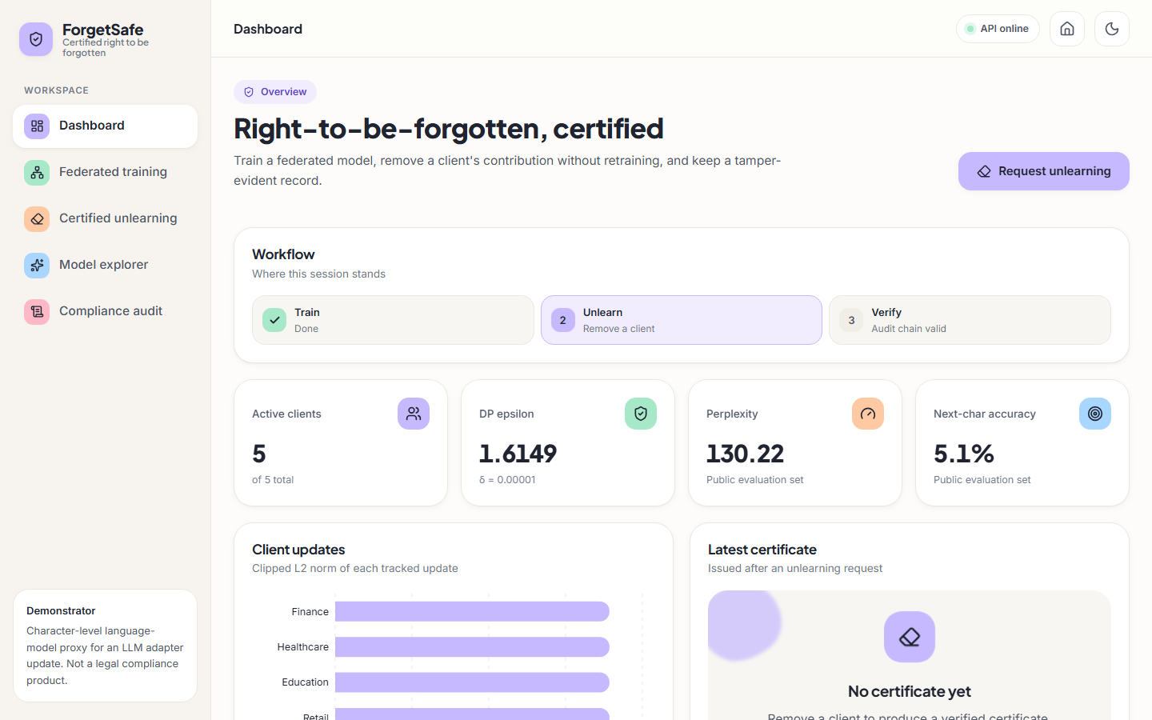  Fig. 4: Dashboard after training: workflow, metrics, client norms

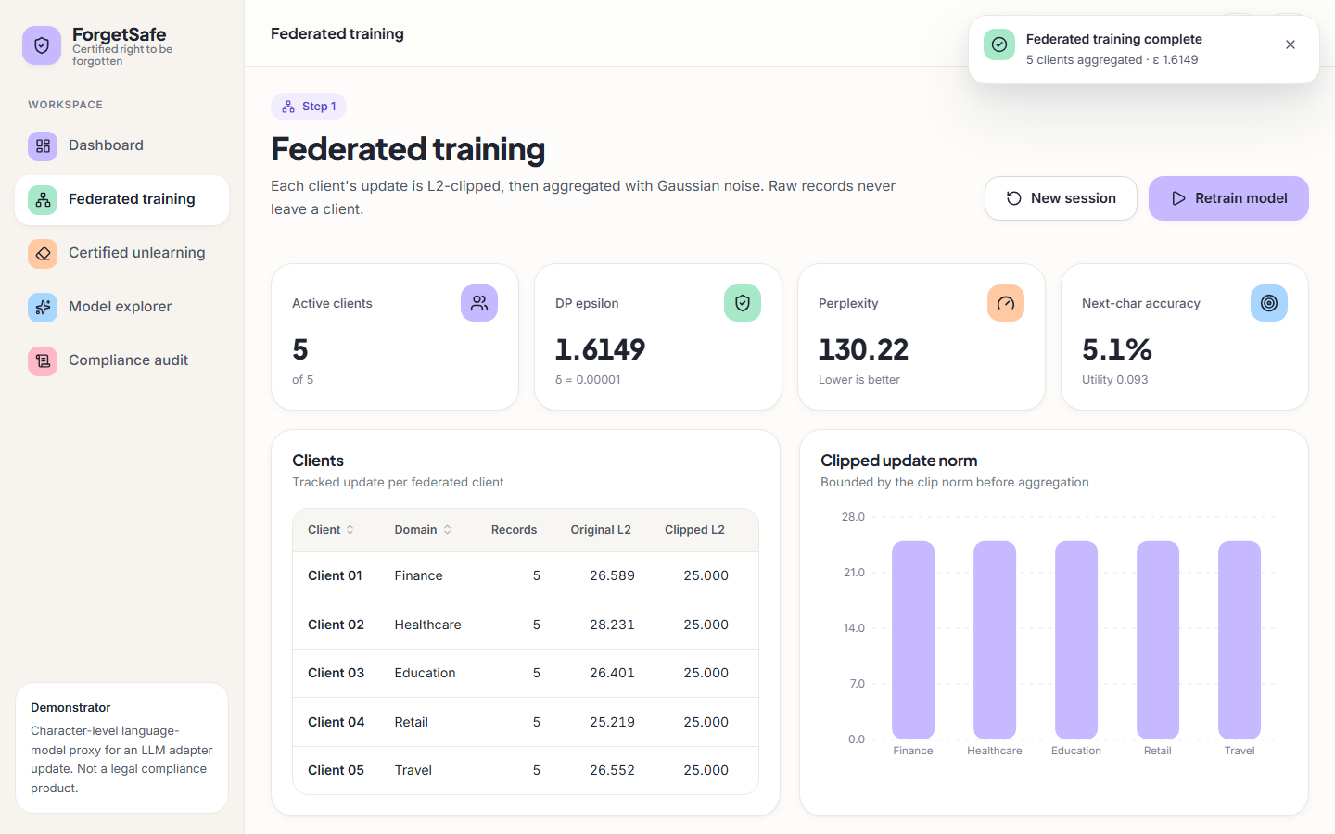  Fig. 5: Federated training page with the clients table and norm chart | 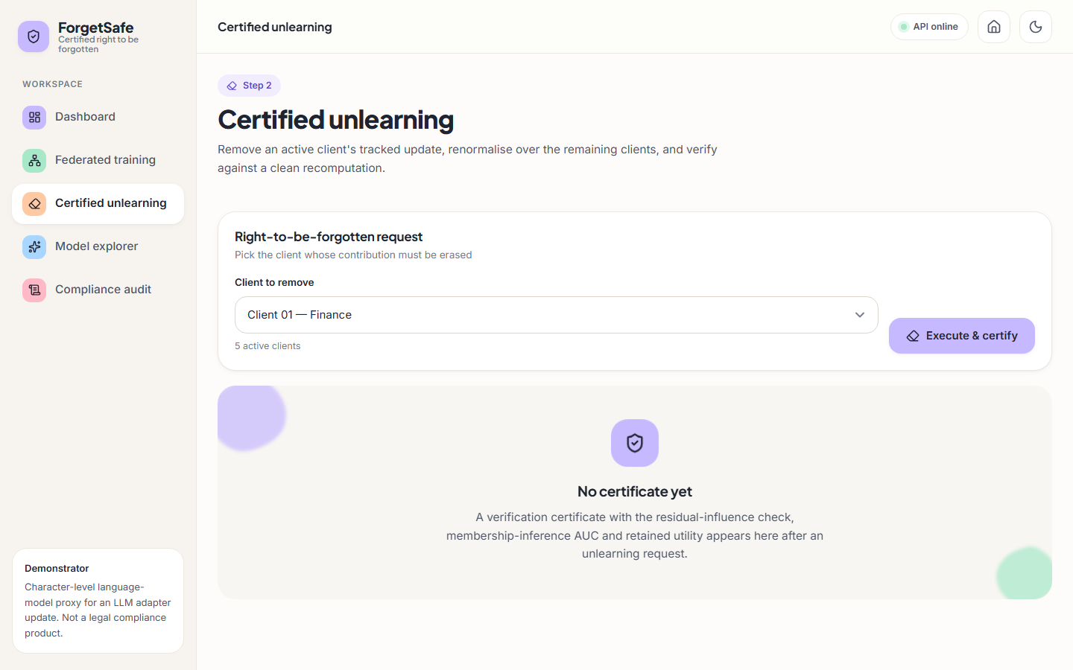  Fig. 6: Right-to-be-forgotten request form

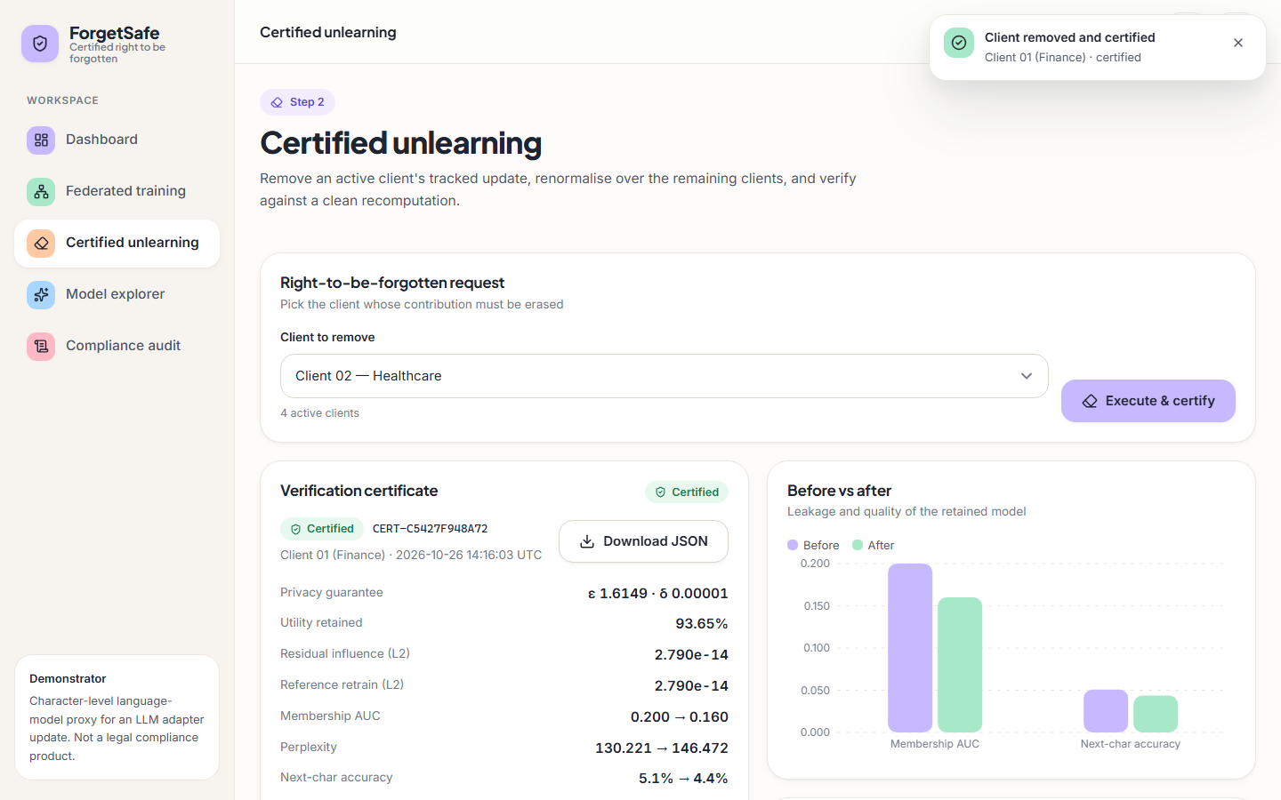  Fig. 7: Verification certificate and before-and-after chart | 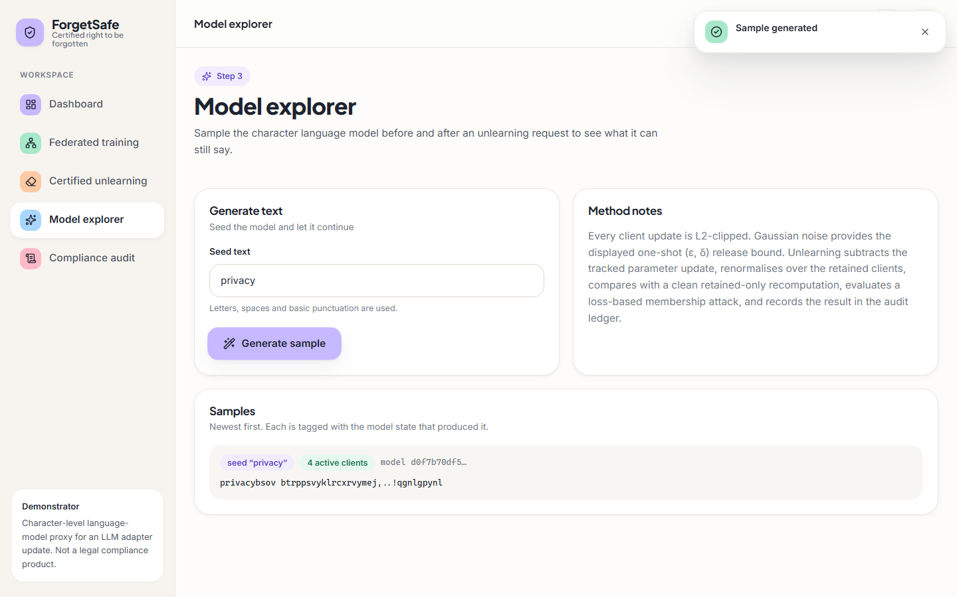  Fig. 8: Model explorer: a sample from the 4-client model

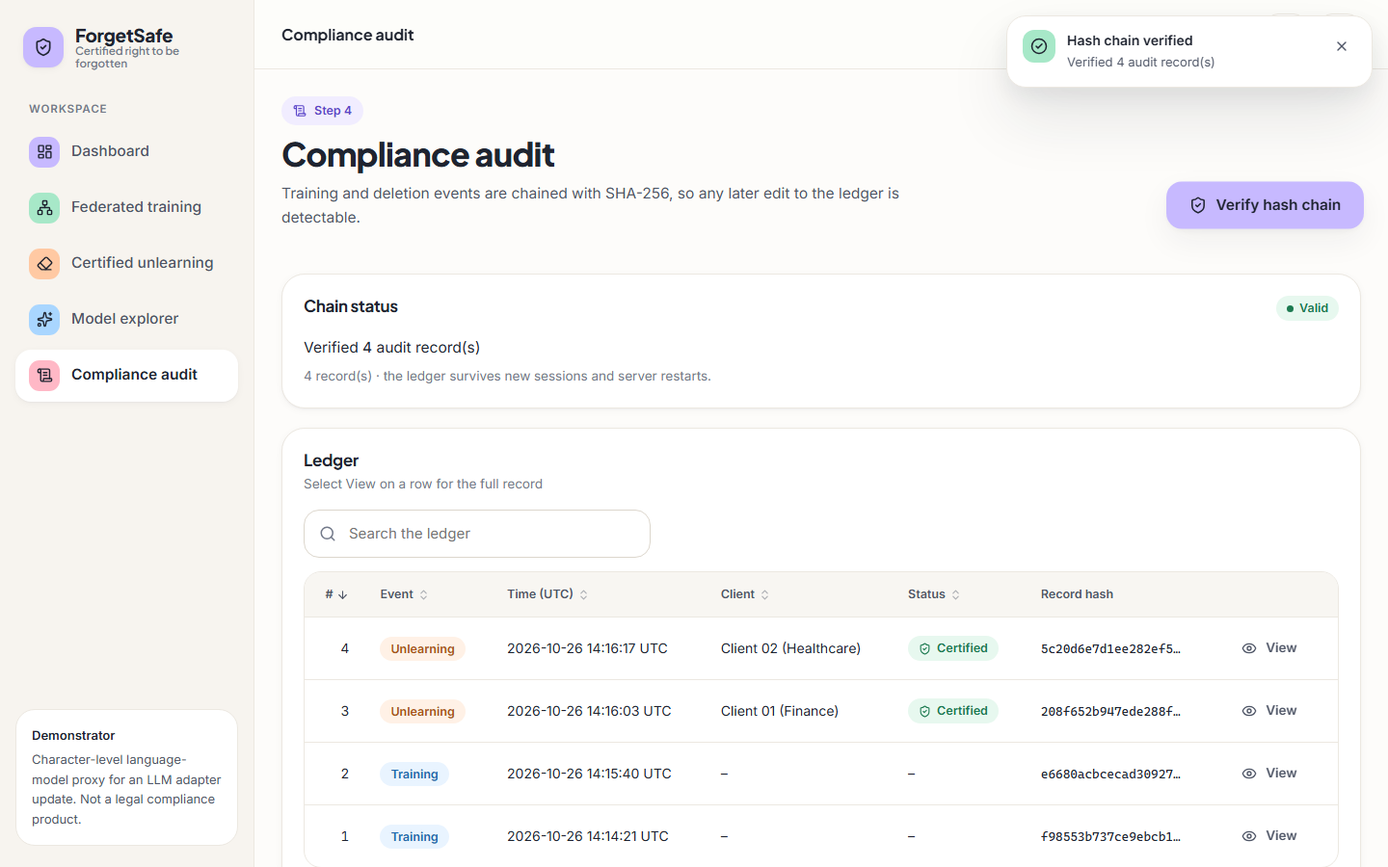  Fig. 9: Compliance audit: chain status and ledger table | 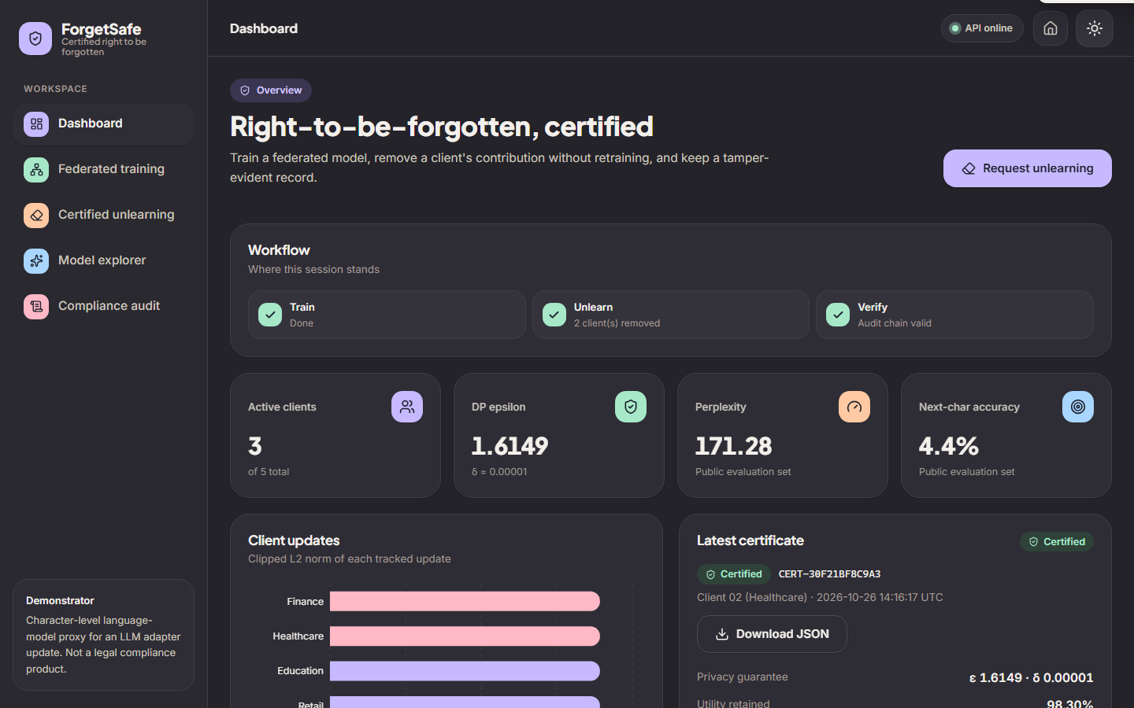  Fig. 10: Dark theme after two removals

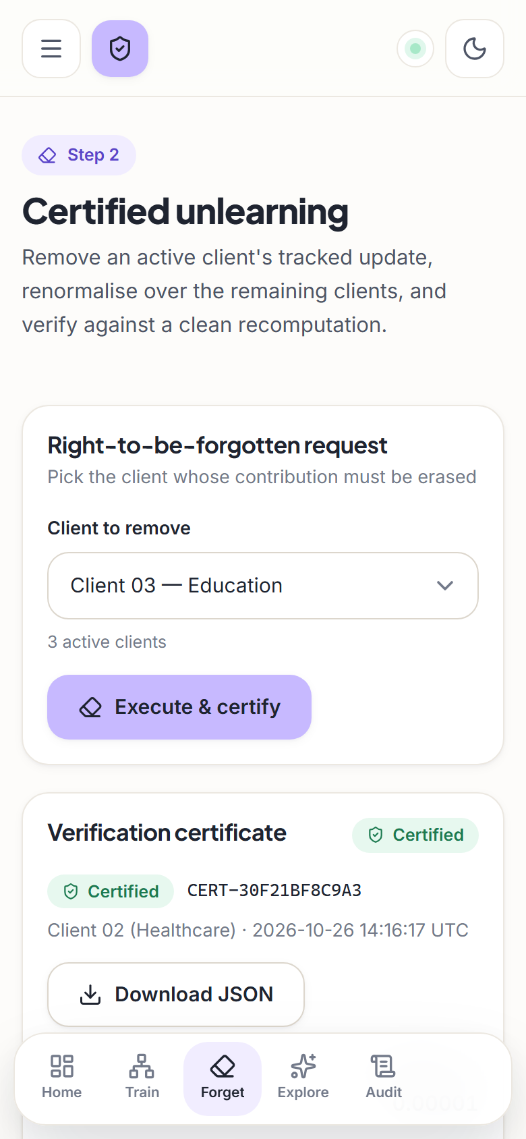  Fig. 11: Unlearning page at 390 px width | 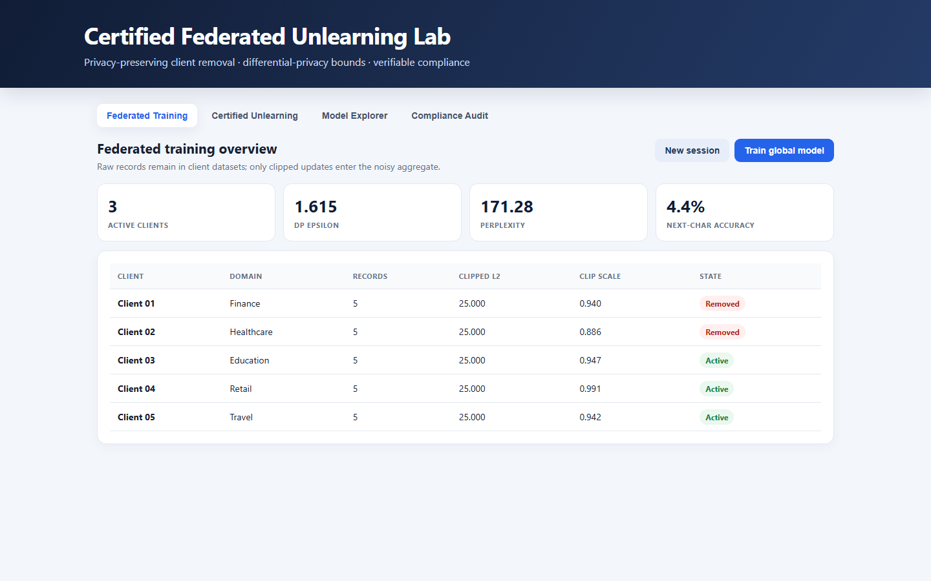  Fig. 12: Original single-page interface, still served at `/` of the API

One limitation of the interface should be recorded. The explorer shows what the model generates, and at the default noise level the text is a string of letters with little structure (the capture in the results chapter shows a sample beginning privacybsov), because the model is noise-dominated. The interface presents the sample honestly as the model's output rather than polishing it, but it also offers no warning that the quality is low; the metric tiles (perplexity 130.22, accuracy 5.1 percent) are the only indication.

10 Installation and Execution
The prerequisites are Python 3.10 or newer, with no third-party packages, and Node.js 18 or newer with npm for the React front end. The system was developed and measured with Python 3.11.9 and Node.js 24.19 on Windows 11.

10.1 One command (Windows)
Listing: starts both servers and opens the browser
run.bat

run.bat reads BACKEND_PORT and FRONTEND_PORT from the environment file when it exists, opens one console for the API (python app.py --port 8109) and one for the UI (npm run dev in frontend), installs frontend/node_modules on the first run, waits four seconds and opens http://127.0.0.1:5109.

10.2 Manual start
Listing: manual start
python app.py --port 8109 # API; also serves the original page at /
cd frontend
npm install
npm run dev # UI on 5109, proxies /api to 8109

Table 12: Ways to run the application
Command | What it starts
python app.py | Original single-page interface on http://127.0.0.1:8000
python app.py --port 8109 | API and original page on the chosen port
python app.py --desktop | Tkinter desktop window
python app.py --demo | Headless demonstration: trains, removes the first client and prints the certificate as JSON
npm run build, npm run preview | Production build of the React front end and a preview server on port 5109

10.3 Tests and measurements
Listing: verification commands
python -m unittest discover -s tests -v # 5 tests
python scripts/smoke_test.py # 14 end-to-end API checks
python scripts/run_experiments.py # writes experiments/*/metrics.json
python scripts/make_charts.py # writes docs/charts/*.png

The smoke test starts its own server on a spare port with a throw-away working directory, so it does not touch the real audit ledger; with --url it tests an already running server instead. The ledger of a normal run is data/audit_log.jsonl under the directory from which the server was started.
Table 13: Troubleshooting
Symptom | Likely cause | Remedy
Page loads but shows 'Could not load the lab' | API not running or on another port | Start python app.py --port 8109; check the ports in the environment file
npm run dev fails with a port error | Port 5109 already in use (strictPort is set) | Stop the other process or change FRONTEND_PORT
Ledger shows a broken chain | The file was edited by hand | Compare the reported record number with the file; delete the file only for a fresh demonstration
Certificates disappear after pressing Train | Training clears the session's certificates | Expected; the ledger keeps the history

